System Centered® Training
Introduction
Germany
Lotte Paans & Dan Tuffy

SCT is an experiential, body-oriented and inter-personal conflict resolution method where differences and our reactions to them are explored rather than acted out, so that the individual, subgroup, and group-as-a-whole can survive, develop and transform.

Central to SCT is ‘Functional Subgrouping’; the core method of SCT which is a communication method based on connection with oneself and others.
In our everyday interactions, we can easily get caught-up over differences. When this happens, communication becomes difficult and the ability to collaborate can stagnate. Through the SCT lens we view this from a larger perspective than “just me” and as we learn to see ourselves and the group as part of a system that has an influence on us, we can begin to take things less personally. Once this happens, we create a climate in which exploring and identifying the underlying dynamics becomes possible. This can bring about sustainable change, within ourselves and others.

The training will be run in English, however members are free to speak German in order to express themselves more clearly.

What will I learn and how will I benefit from this introductory training?
- I will learn to use the core SCT skill of ‘functional subgrouping’ to explore experience in the here-and-now with the group
- I will learn to identify and reduce noise in communication
- I will learn how group dynamics impacts our autonomous nervous systems and how our behaviour then impacts the climate of the group
- I will benefit from having more options available to me than my habitual responses when triggered
- I will benefit from learning skills that regulate arousal states within myself in co-regulation with others
- I will benefit by learning to identify the source of my anxiety, to undo it and to move into reality

Background
The systems-centered approach to group and organizational work has been in the field for over 25 years, presented in over 30 articles in professional journals. SCT practice has its theoretical basis in Yvonne Agazarians “Theory of Living Human Systems”. Its methods incorporate techniques linked to successful strategies for development in group and individual psychotherapy, for example: modifying cognitive distortions, increasing group cohesion, lowering scapegoating, and reducing somatic defenses.
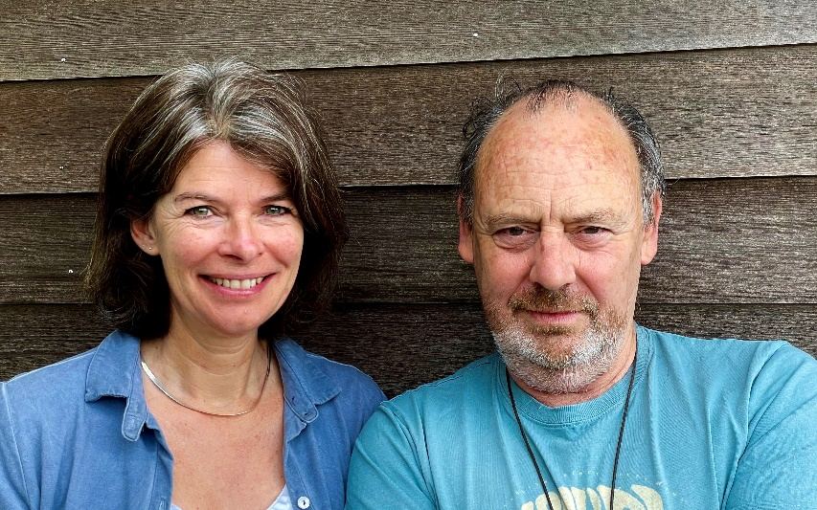 | Lotte Paans (ir) is a Licensed SCT-Practitioner, co-founder and chair of SCT-Nederland, member of the SCTRI Systems-Centered Training Research Institute and works as a (international) trainer, (team)coach, consultant and (couples)therapist.  Dan Tuffy is in SCT leadership training, is a member of the SCTRI and works as a (youth) coach, consultant, (couples) therapist, trainer and musician.

Sat/Sun: 24. / 25. February 2024, 9:30-17:30 h (incl. 90 min lunch break)
Costs: € 400,-
Location: FREIRAUM, Saarstraße 5, 80797 München (Schwabing)
There will be a follow up series of online sessions for deepening of the work. Participation in the SCT introduction is a prerequisite for membership of the follow up sessions.

For all enquiries about registration, dates and costs please don’t hesitate to contact
Birgit Wolff: info@dr-birgit-wolff.de or 089 12127915.
SCT® and Systems-Centered® are registered trademarks of the Systems-Centered Training and Research Institute

