System Centered® Training
Foundation
Germany
Lotte Paans & Dan Tuffy

SCT is an experiential, body-oriented and inter-personal conflict resolution method where differences and our reactions to them are explored rather than acted out, so that the individual, subgroup, and group-as-a-whole can survive, develop and transform.

Central to SCT is ‘Functional Subgrouping’; the core method of SCT which is a communication method based on connection with oneself and others.
In our everyday interactions, we can easily get caught-up over differences. When this happens, communication becomes difficult and the ability to collaborate can stagnate. Through the SCT lens we view this from a larger perspective than “just me” and as we learn to see ourselves and the group as part of a system that has an influence on us, we can begin to take things less personally. Once this happens, we create a climate in which exploring and identifying the underlying dynamics becomes possible. This can bring about sustainable change, within ourselves and others.

The training will be run in English, however members are free to speak German in order to express themselves more clearly.

What will I learn and how will I benefit from this training?
- I will learn to use the core SCT skill of ‘functional subgrouping’ to explore experience in the here-and-now with the group
- I will learn to identify and reduce noise in communication
- I will learn how group dynamics impacts our autonomous nervous systems and how our behaviour then impacts the climate of the group
- I will benefit from having more options available to me than my habitual responses when triggered
- I will benefit from learning skills that regulate arousal states within myself in co-regulation with others
- I will benefit by learning to identify the source of my anxiety, to undo it and to move into reality

Background
The systems-centered approach to group and organizational work has been in the field for over 30 years, presented in numerous articles in professional journals. SCT practice has its theoretical basis in Yvonne Agazarian’s “Theory of Living Human Systems”. Its methods incorporate techniques linked to successful strategies for development in group and individual psychotherapy, for example: modifying cognitive distortions, increasing group cohesion, lowering scapegoating, and reducing somatic defenses.
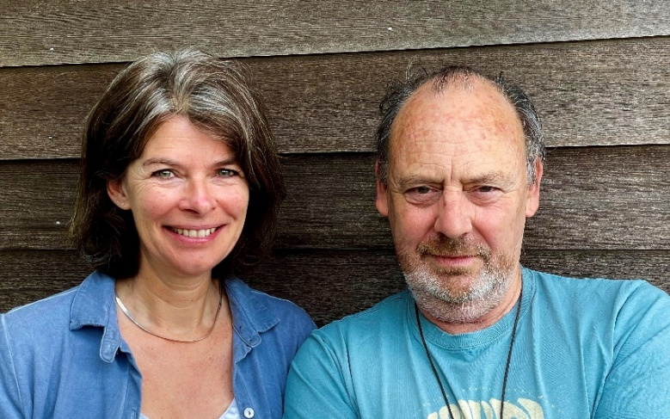 | Lotte Paans (ir) is a Licensed SCT-Practitioner, co-founder and chair of SCT-Nederland, member of the SCTRI Systems-Centered Training Research Institute and works as a (international) trainer, (team)coach, consultant and (couples)therapist.  Dan Tuffy is in SCT leadership training, is a member of the SCTRI and works as a (youth) coach, consultant, (couples) therapist, trainer and musician.
For all enquiries about registration, dates and costs please don’t hesitate to contact Birgit Wolff:
info@dr-birgit-wolff.de or +49 1797479813.
2026
In Person Weekend: Feb 28/March 1 and Jul 4/5 (9:30 - 17:40)
Costs: Early Bird before Jan 15 and May 15: € 430, thereafter € 480
Location: Veranstaltungsraum, Heinrich-Böll-Str. 75, 81829 München
In addition there are four online meetings that are part of the Ongoing Group work.
We recommend you attend them (although attendance is optional).
Online: Jan 19, Mar 30, May 18, Oct 19, Nov 9 reserve date (14:00 - 17:30) € 430.

2027
In Person weekend: March 13/14 and Oct 23/24 (9:30 - 17:40)
In addition there are eight online meetings that are part of the Ongoing Group work.
We recommend you attend them (although attendance is optional).
Online: Jan 25, Feb 22, Apr 5, May 3, Jun 21, Sep 6, Oct 11, Nov 15 (15:00 - 17:00)
Reserve Dates: Jun 28 (15:00 - 17:00), Dec 6 (8:30 - 10:30)

SCT® and Systems-Centered® are registered trademarks of the Systems-Centered Training and Research Institute

